eMart Project Design

1. Introduction 1

2. Main functions of the system 1

2.1 System Use Cases 1

2.1.1 Buyer User Cases 1

2.1.2 Seller User Cases 2

2.1.3 Seller User Cases 2

2.2 System UI Pages 3

2.2.1 Buyer UI Pages 3

2.2.2 Seller UI Pages 3

2.2.3 Admin UI Pages 3

3. Data Model 3

4. Database table design 3

4.1 Buyer Table 3

4.2 Seller Table 4

4.3 Category Table 4

4.4 Subcategory Table 4

4.5 Transactions Table 5

4.6 Items Table 5

4.7 PurchaseHistory Table 5

4.8 Discounts Table 6

# 

# 1. Introduction

eMart is an online eCommerce portal used to search and buy an item online. Buyer can add items to the cart, checkout and perform other operations. Admin can block/unblock Seller, Buyer, selling items.

# 2. Main functions of the system

## 2.1 System Use Cases

### 2.1.1 Buyer User Cases

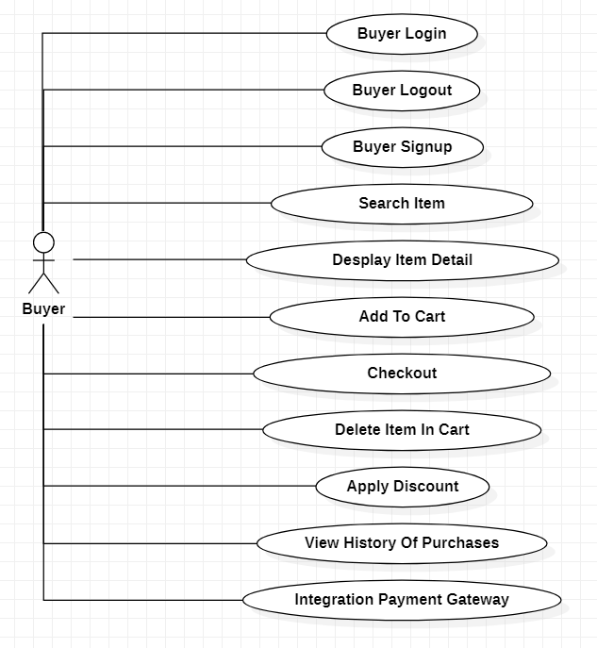

### 2.1.2 Seller User Cases

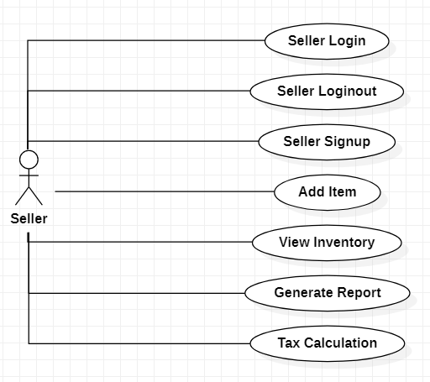

### 2.1.3 Admin User Cases

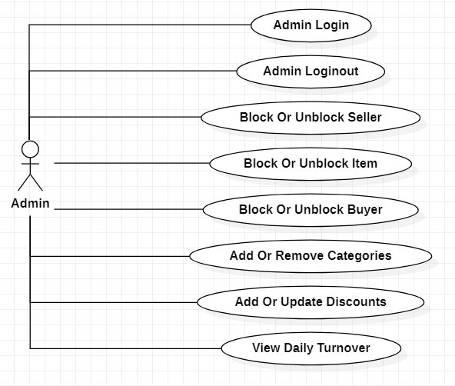

## 2.2 System UI Pages

### 2.2.1 Buyer UI Pages

Login Page:

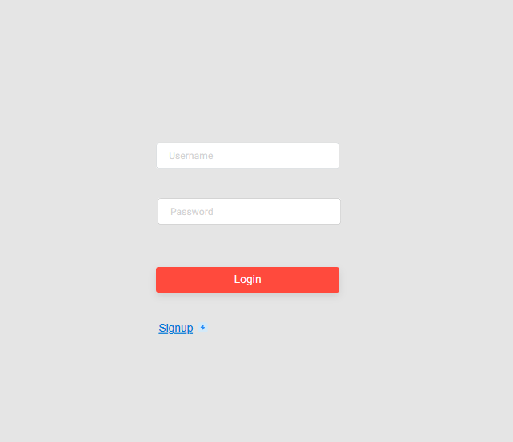

Signup Page:

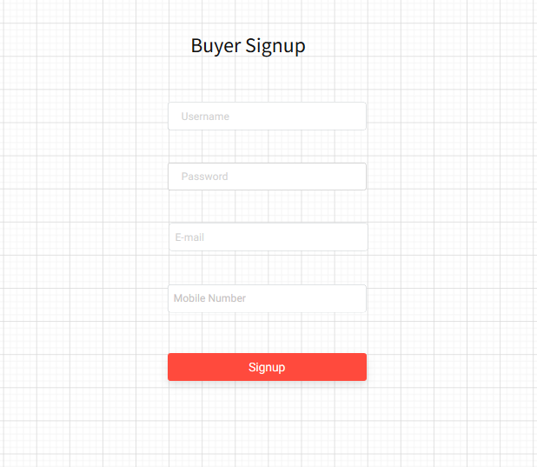

Search Page:

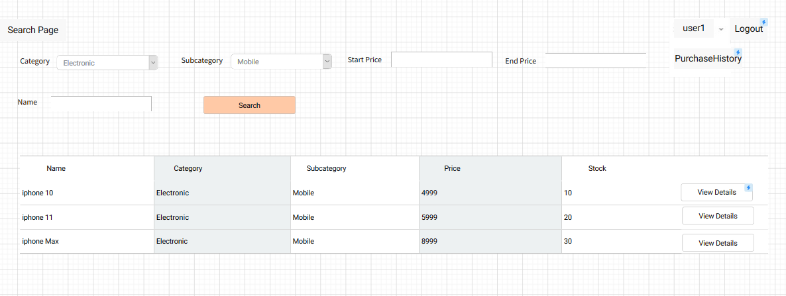

Item Detail Page:

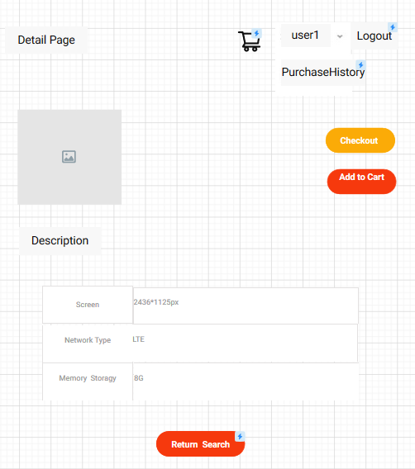

Shopping Cart Page:

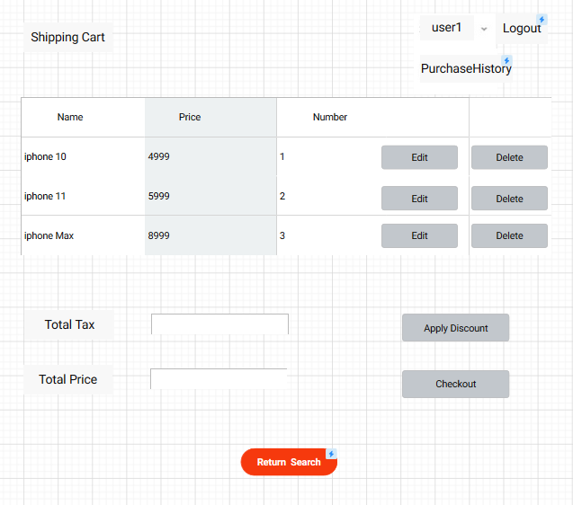

Item Checkout Page:

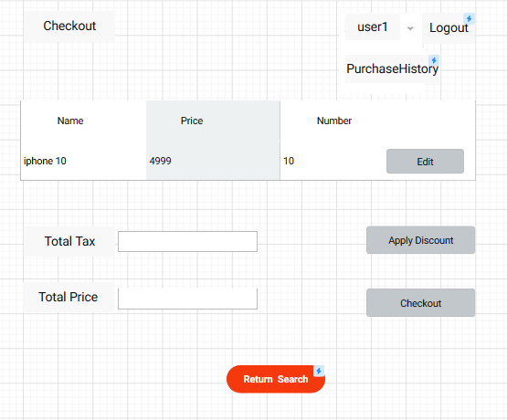

Purchase History:

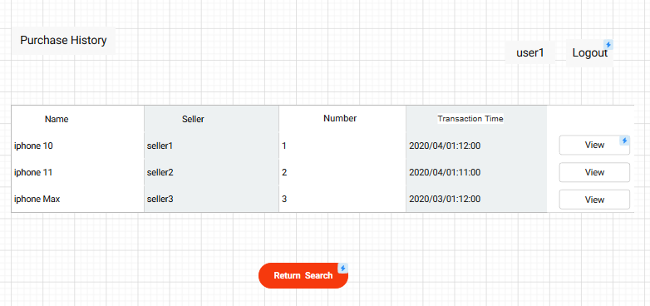

### 2.2.2 Seller UI Pages

Login Page:



Signup Page:

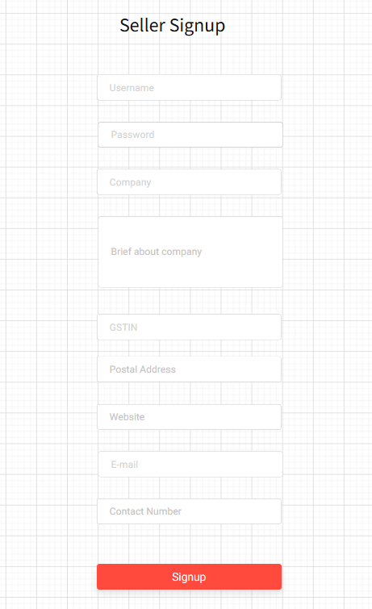

Add Item:

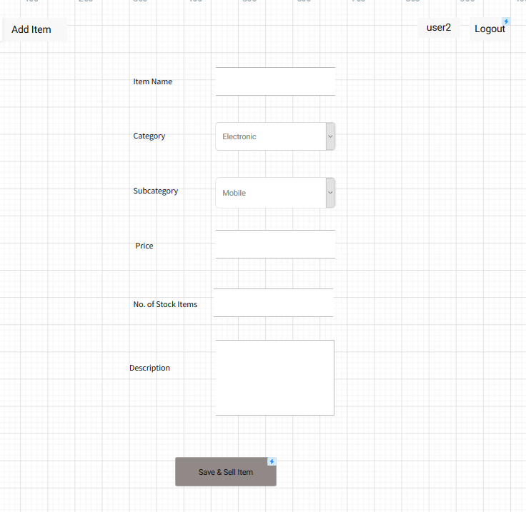

View Inventory:

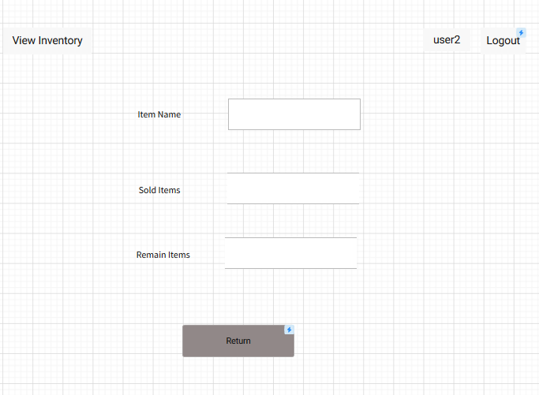

### 2.2.3 Admin UI Pages(optional)

# 3. Data Model

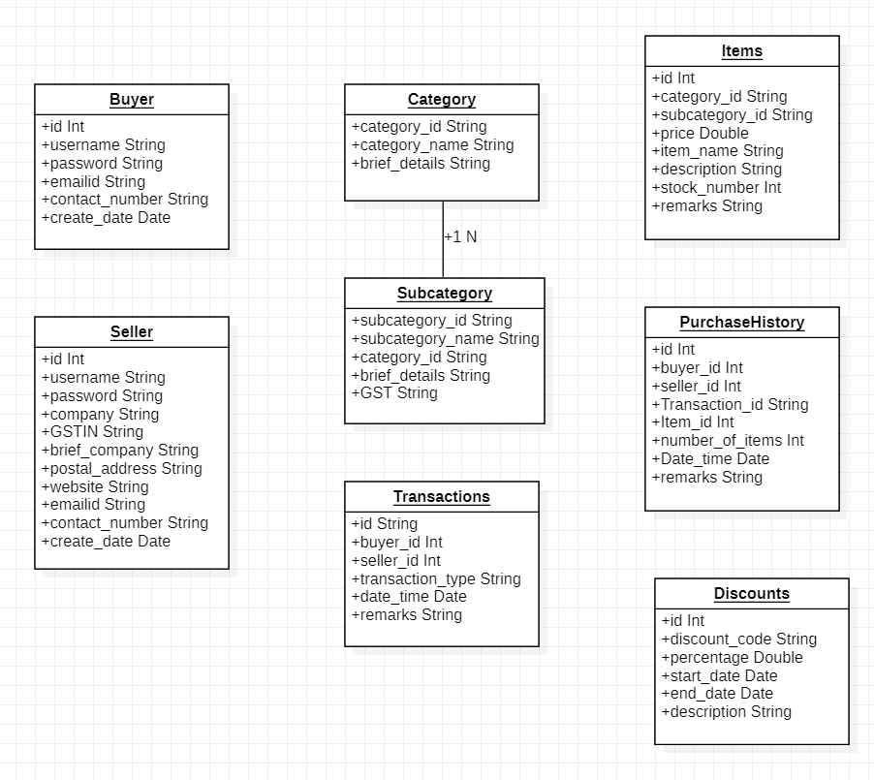

# 4. Database table design

## 4.1 Buyer Table

|  |  |  |  |  |
| --- | --- | --- | --- | --- |
| Field | Type | Primary key | Not Null | Description |
| id | INT | PK | Not Null | AUTO_INCREMENT |
| username | VARCHAR(30) |  | Not Null |  |
| password | VARCHAR(50) |  | Not Null |  |
| emailid | VARCHAR(50) |  |  |  |
| contact_number | CHAR(13) |  | Not Null |  |
| create_date | DATE |  |  |  |

## 4.2 Seller Table

|  |  |  |  |  |
| --- | --- | --- | --- | --- |
| Field | Type | Primary key | Not Null | Description |
| id | INT | PK | Not Null | AUTO_INCREMENT |
| username | VARCHAR(30) |  | Not Null |  |
| password | VARCHAR(50) |  | Not Null |  |
| company | VARCHAR(30) |  | Not Null |  |
| GSTIN | VARCHAR(10) |  |  |  |
| brief_company | VARCHAR(255) |  |  |  |
| postal_address | VARCHAR(100) |  |  |  |
| website | VARCHAR(30) |  |  |  |
| emailid | VARCHAR(50) |  |  |  |
| contact_number | CHAR(13) |  | Not Null |  |
| create_date | DATE |  |  |  |

## 4.3 Category Table

|  |  |  |  |  |
| --- | --- | --- | --- | --- |
| Field | Type | Primary key | Not Null | Description |
| category_id | VARCHAR(30) | PK | Not Null |  |
| category_name | VARCHAR(30) |  | Not Null |  |
| brief_details | VARCHAR(255) |  |  |  |

## 4.4 Subcategory Table

|  |  |  |  |  |
| --- | --- | --- | --- | --- |
| Field | Type | Primary key | Not Null | Description |
| subcategory_id | VARCHAR(30) | PK | Not Null |  |
| subcategory_name | VARCHAR(30) |  | Not Null |  |
| category_id | VARCHAR(30) |  | Not Null |  |
| brief_details | VARCHAR(250) |  |  |  |
| GSTIN | VARCHAR(10) |  |  |  |

## 4.5 Transactions Table

|  |  |  |  |  |
| --- | --- | --- | --- | --- |
| Field | Type | Primary key | Not Null | Description |
| id | VARCHAR(30) | PK | Not Null |  |
| buyer_id | INT |  | Not Null |  |
| seller_id | INT |  | Not Null |  |
| transaction_type | VARCHAR(10) |  |  |  |
| date_time | DATE |  |  |  |
| remarks | VARCHAR(50) |  |  |  |

## 4.6 Items Table

|  |  |  |  |  |
| --- | --- | --- | --- | --- |
| Field | Type | Primary key | Not Null | Description |
| id | INT | PK | Not Null |  |
| category_id | VARCHAR(30) |  | Not Null |  |
| subcategory_id | VARCHAR(30) |  | Not Null |  |
| price | DECIMAL(10,2) |  | Not Null |  |
| item_name | VARCHAR(30) |  | Not Null |  |
| description | VARCHAR(50) |  |  |  |
| stock_number | INT |  |  |  |
| remarks | VARCHAR(50) |  |  |  |

## 4.7 PurchaseHistory Table

|  |  |  |  |  |
| --- | --- | --- | --- | --- |
| Field | Type | Primary key | Not Null | Description |
| id | INT | PK | Not Null |  |
| buyer_id | INT |  | Not Null |  |
| seller_id | INT |  | Not Null |  |
| Transaction_id | VARCHAR(30) |  | Not Null |  |
| Item_id | INT |  | Not Null |  |
| number_of_items | INT |  |  |  |
| Date_time | DATE |  |  |  |
| remarks | VARCHAR(50) |  |  |  |

## 4.8 Discounts Table

|  |  |  |  |  |
| --- | --- | --- | --- | --- |
| Field | Type | Primary key | Not Null | Description |
| id | INT | PK | Not Null |  |
| discount_code | VARCHAR(50) |  | Not Null |  |
| percentage | DECIMAL(2,0) |  | Not Null |  |
| start_date | DATE |  | Not Null |  |
| end_date | DATE |  | Not Null |  |
| description | VARCHAR(255) |  |  |  |